Test Case: tc001_SPX_Dev5_Crear_Nueva_Linea_Requisicion_Spot_Tipo_Cobro_CC
Step 1 - Enter username and password and click to button Enter : Credentials Entered
Image file-name: QC_Testing-tc001_SPX_Dev5_Crear_Nueva_Linea_Requisicion_Spot_Tipo_Cobro_CC-1790175079347

Step 2 - Select to UEN and Access to Spot Buy Requisitions : UEN Correctly selected and Correct access
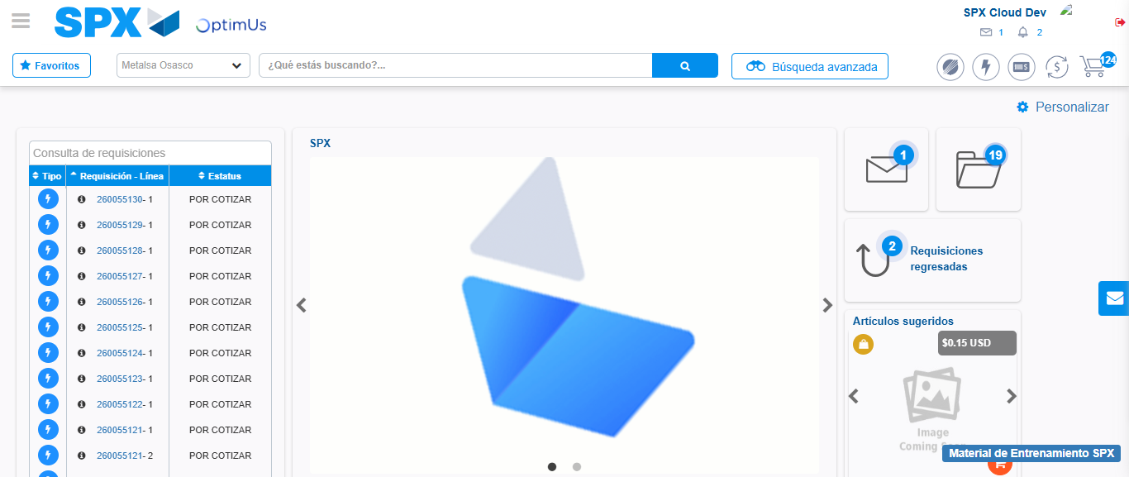Image file-name: QC_Testing-tc001_SPX_Dev5_Crear_Nueva_Linea_Requisicion_Spot_Tipo_Cobro_CC-1790175103872

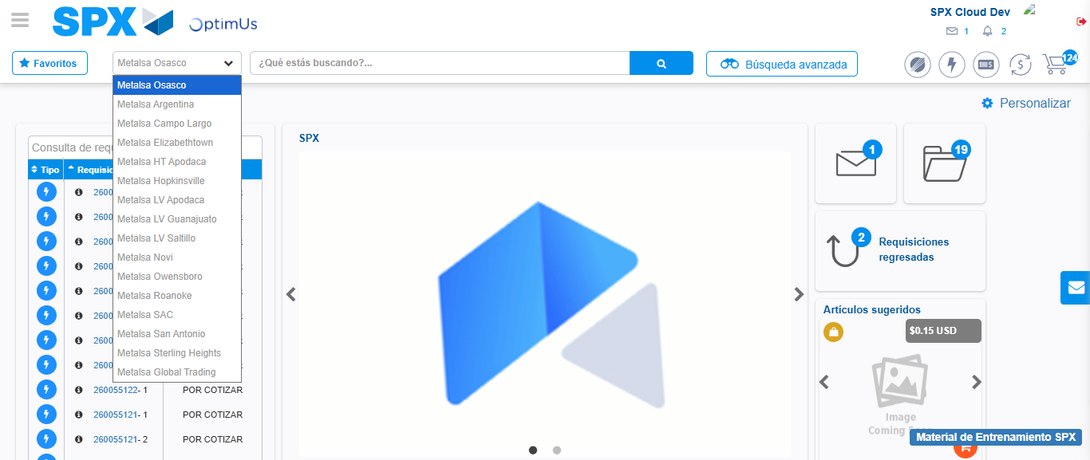Image file-name: QC_Testing-tc001_SPX_Dev5_Crear_Nueva_Linea_Requisicion_Spot_Tipo_Cobro_CC-1790175104576

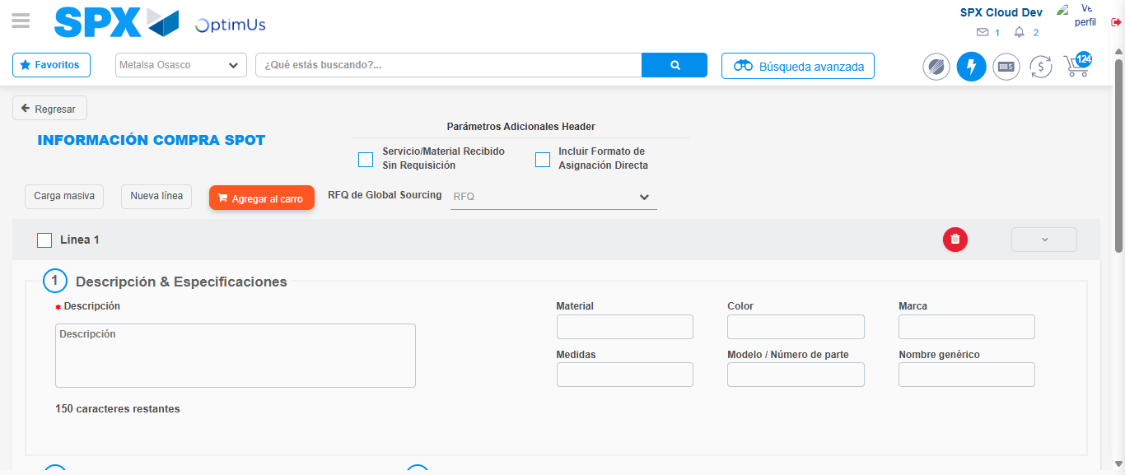Image file-name: QC_Testing-tc001_SPX_Dev5_Crear_Nueva_Linea_Requisicion_Spot_Tipo_Cobro_CC-1790175109076

Step 3 - Data Capture Spot Buy Requisition: Data captured correctly
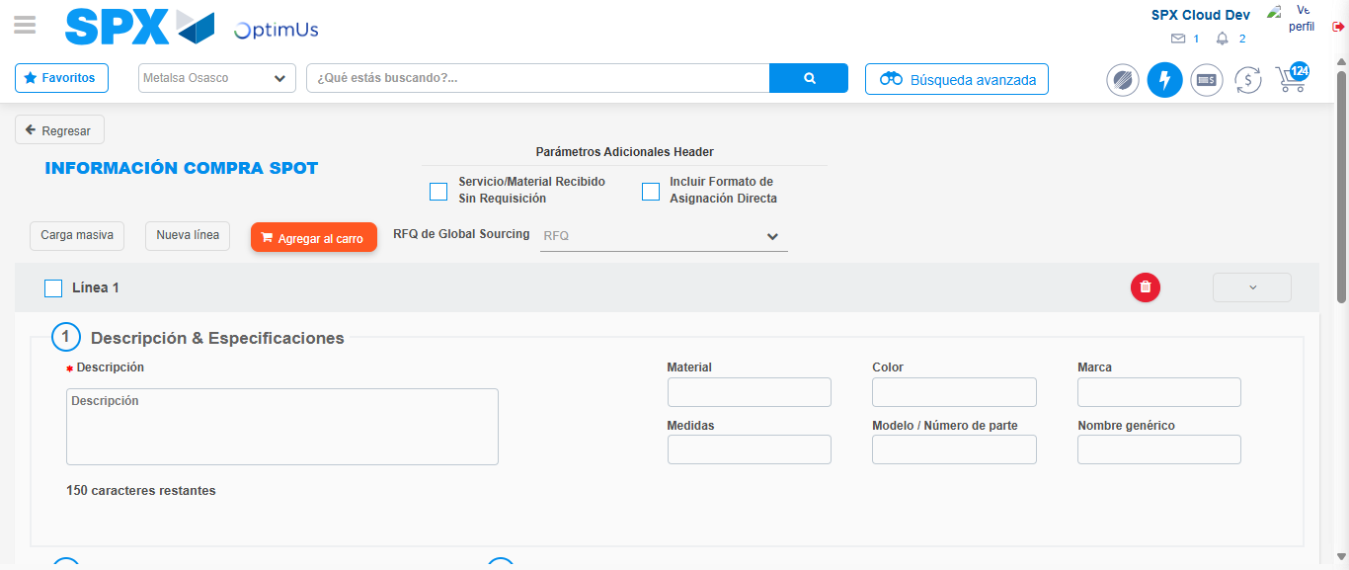Image file-name: QC_Testing-tc001_SPX_Dev5_Crear_Nueva_Linea_Requisicion_Spot_Tipo_Cobro_CC-1790175109402

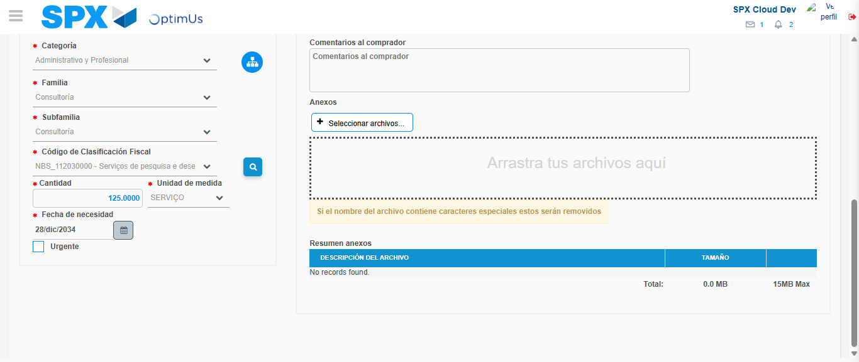Image file-name: QC_Testing-tc001_SPX_Dev5_Crear_Nueva_Linea_Requisicion_Spot_Tipo_Cobro_CC-1790175131503

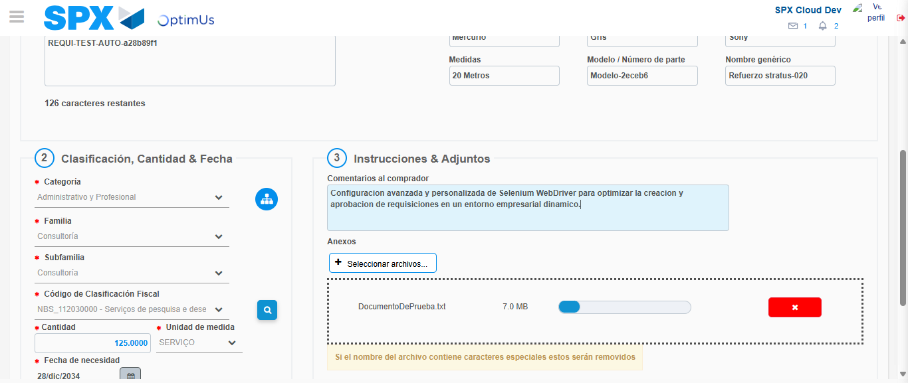Image file-name: QC_Testing-tc001_SPX_Dev5_Crear_Nueva_Linea_Requisicion_Spot_Tipo_Cobro_CC-1790175132444

Step 4 - Add new line and data capture second line: Line add correctly
Image file-name: QC_Testing-tc001_SPX_Dev5_Crear_Nueva_Linea_Requisicion_Spot_Tipo_Cobro_CC-1790175109402

Image file-name: QC_Testing-tc001_SPX_Dev5_Crear_Nueva_Linea_Requisicion_Spot_Tipo_Cobro_CC-1790175131503

Image file-name: QC_Testing-tc001_SPX_Dev5_Crear_Nueva_Linea_Requisicion_Spot_Tipo_Cobro_CC-1790175132444

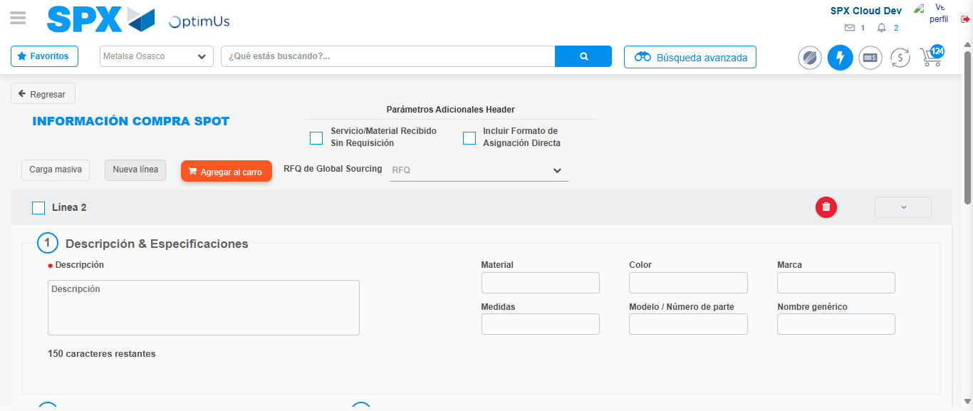Image file-name: QC_Testing-tc001_SPX_Dev5_Crear_Nueva_Linea_Requisicion_Spot_Tipo_Cobro_CC-1790175134832

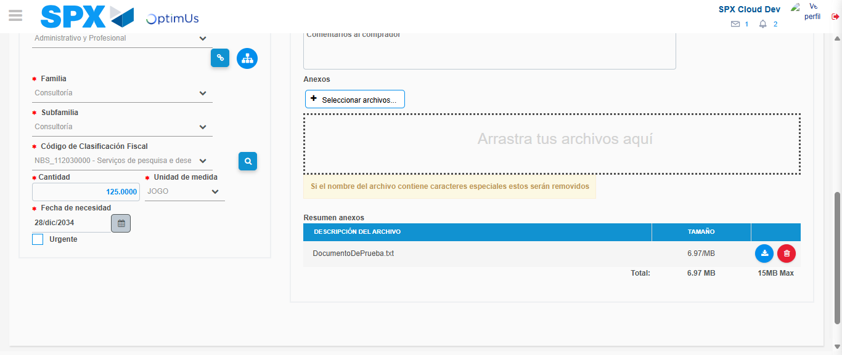Image file-name: QC_Testing-tc001_SPX_Dev5_Crear_Nueva_Linea_Requisicion_Spot_Tipo_Cobro_CC-1790175152413

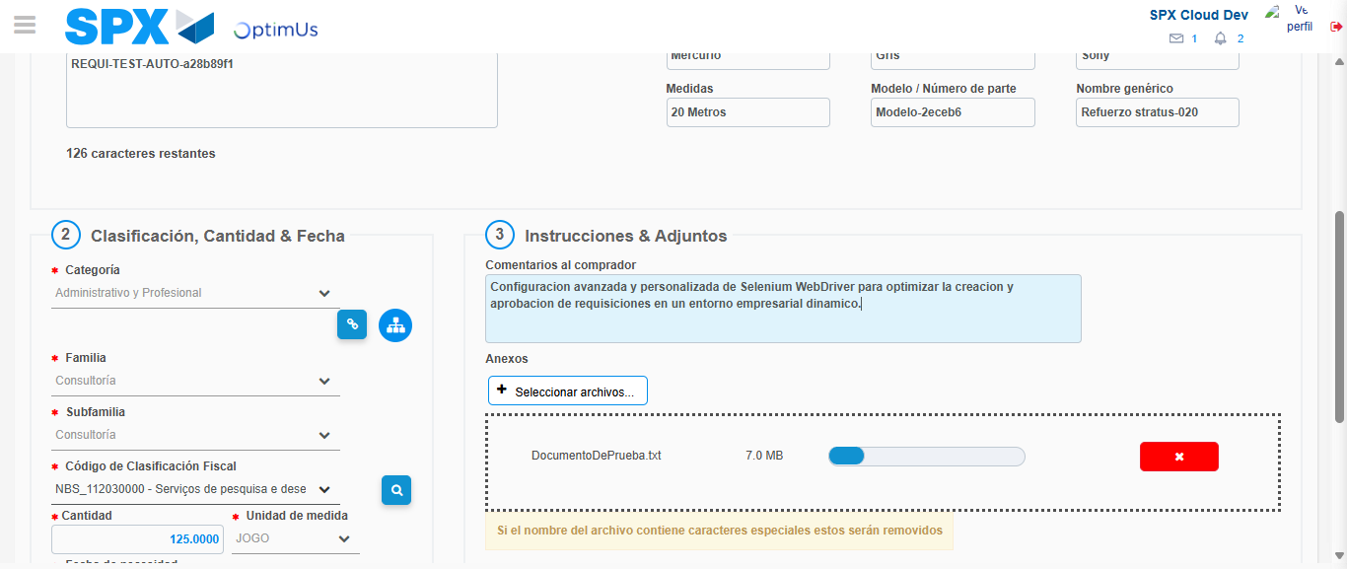Image file-name: QC_Testing-tc001_SPX_Dev5_Crear_Nueva_Linea_Requisicion_Spot_Tipo_Cobro_CC-1790175153498

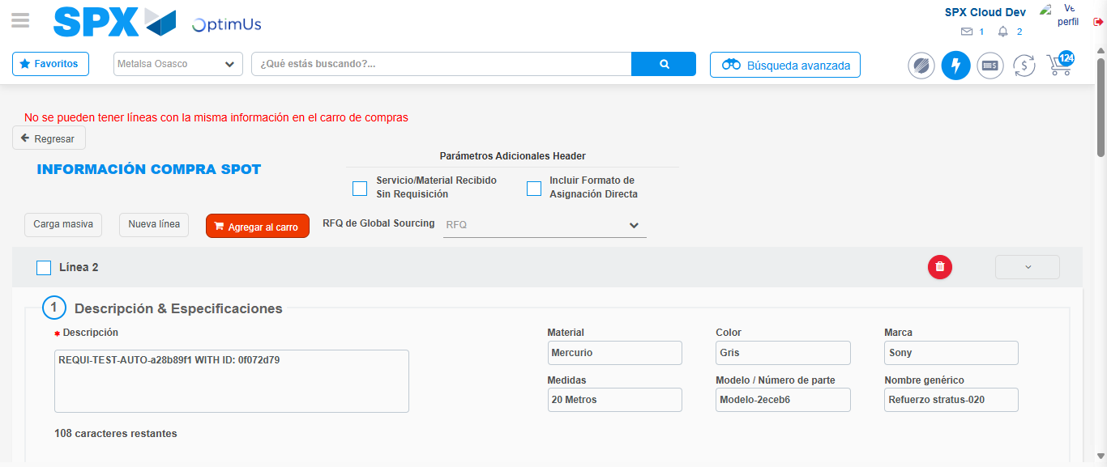Image file-name: QC_Testing-tc001_SPX_Dev5_Crear_Nueva_Linea_Requisicion_Spot_Tipo_Cobro_CC-1790175158487

Step 8 - Return to Main Page SPX : Return to Main Page SPX
Image file-name: QC_Testing-tc001_SPX_Dev5_Crear_Nueva_Linea_Requisicion_Spot_Tipo_Cobro_CC-1790175103872

Image file-name: QC_Testing-tc001_SPX_Dev5_Crear_Nueva_Linea_Requisicion_Spot_Tipo_Cobro_CC-1790175104576

Image file-name: QC_Testing-tc001_SPX_Dev5_Crear_Nueva_Linea_Requisicion_Spot_Tipo_Cobro_CC-1790175109076

Image file-name: QC_Testing-tc001_SPX_Dev5_Crear_Nueva_Linea_Requisicion_Spot_Tipo_Cobro_CC-1790175160801

Image file-name: QC_Testing-tc001_SPX_Dev5_Crear_Nueva_Linea_Requisicion_Spot_Tipo_Cobro_CC-1790175161019

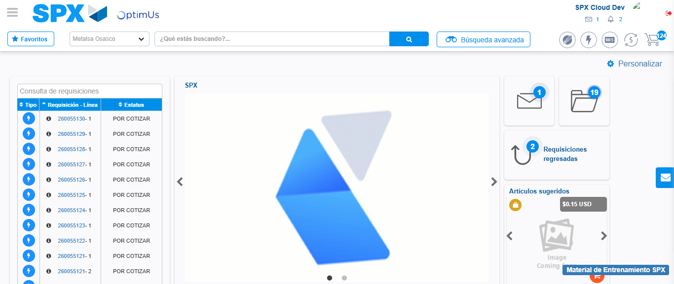Image file-name: QC_Testing-tc001_SPX_Dev5_Crear_Nueva_Linea_Requisicion_Spot_Tipo_Cobro_CC-1790175182195

Step 9 - Log Out : Log Out SPX
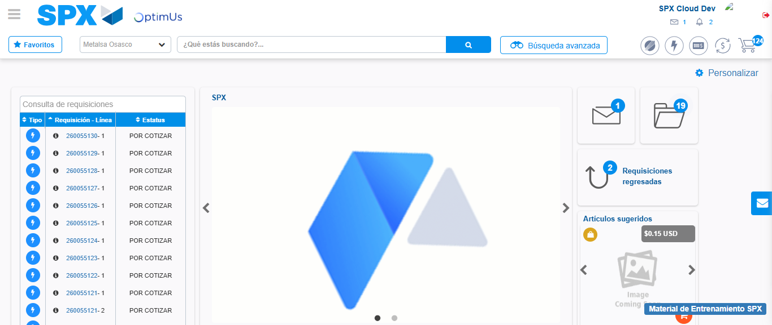Image file-name: QC_Testing-tc001_SPX_Dev5_Crear_Nueva_Linea_Requisicion_Spot_Tipo_Cobro_CC-1790175182550

